The purpose of this document is to provide a snapshot of each page of the current Vendor Registration Form. This document is provided so that you can preview what information is requested, on each page, prior to accessing the form itself. Note that any field marked with an asterisk “*” is mandatory. You will not be able to complete your registration until at least that information is entered.
As there is no way for you to save your information and complete the form at a later time, if you leave the form or close your browser, you will lose all entered information and must re-enter everything to complete the registration. There is also the possibility that you may timeout if you are inactive too long on any page. If this happens, you will lose all entered information and must re-enter everything to complete the registration. Therefore:

Please have all necessary and desired information readily available prior to starting the vendor registration form

Contents
OVERVIEW OF ALL FIVE (5) PAGES OF THE VENDOR REGISTRATION FORM 2
Page 1 2
Page 2 3
Page 3 4
Page 4 6
Page 5 7

OVERVIEW OF ALL FIVE (5) PAGES OF THE VENDOR REGISTRATION FORM

Page 1
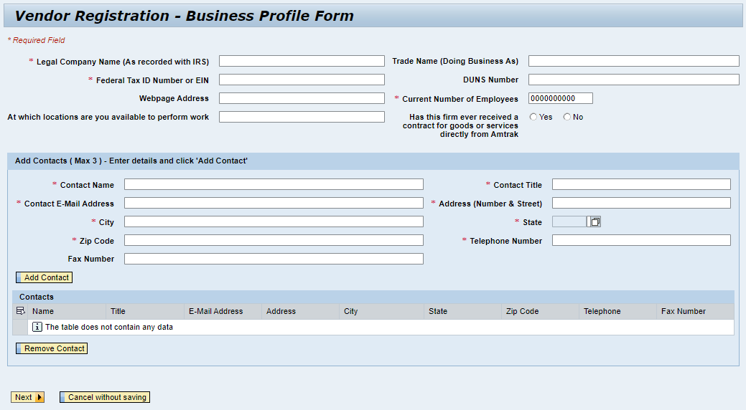

Page 2
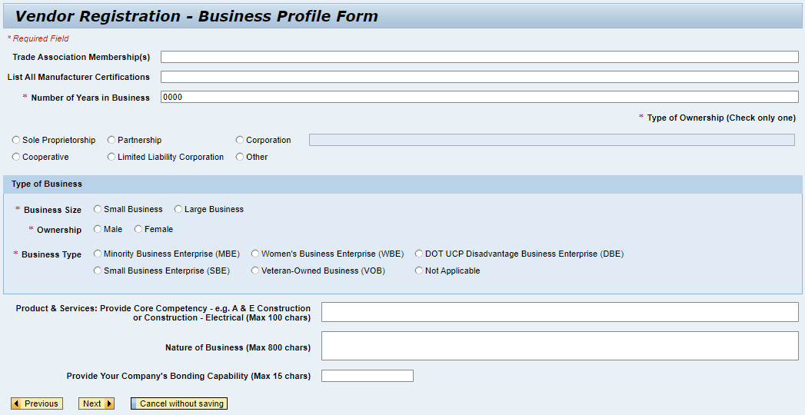

Page 3
Note - This page only appears if the Business Type selected on Page 2 is not “Not Applicable”. If “Not Applicable” is selected, then page 4 will be displayed after page 2, skipping this page (page 3). If page 3 is required, then after page 3, the form continues to page 4.
Note – In the section “NAICS Codes and Descriptions - (NAICS Codes must be included in DOT or SBA certifications)”, the field requesting the NAICS Codes and the field requesting the NAICS Codes’ Descriptions are mandatory if the Business Size selected on page 2 is “Small Business”, otherwise the NAICS Codes and Descriptions are not mandatory if the Business Size selected on page 2 is “Large Business”
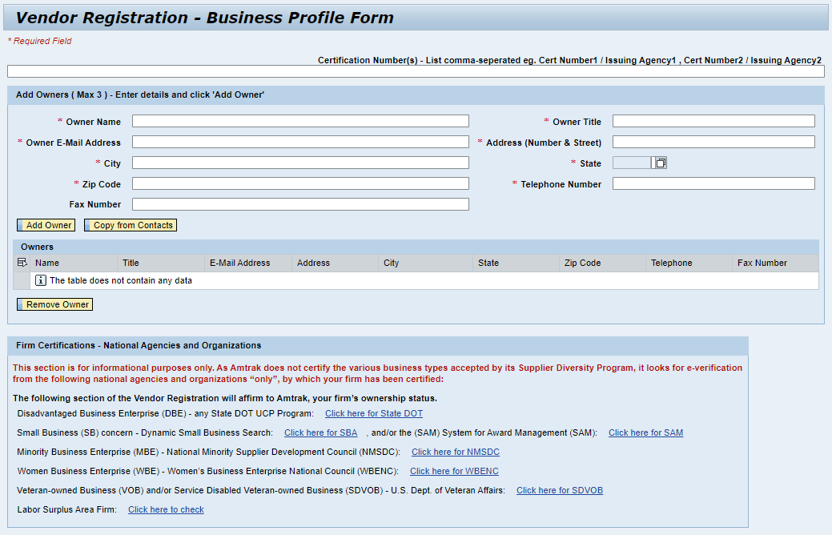

Page 3 (continued)
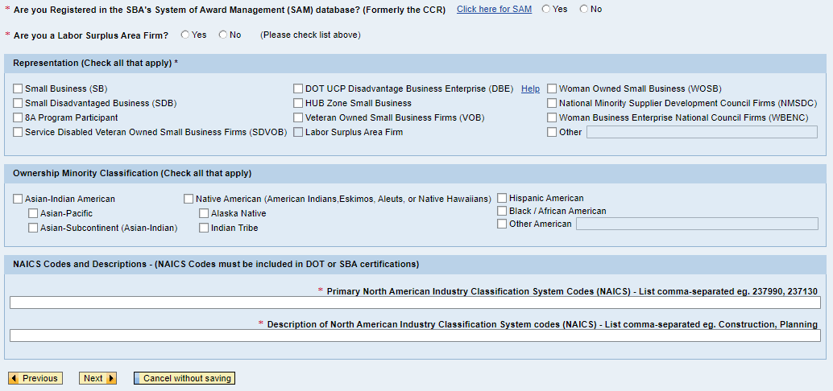

Page 4
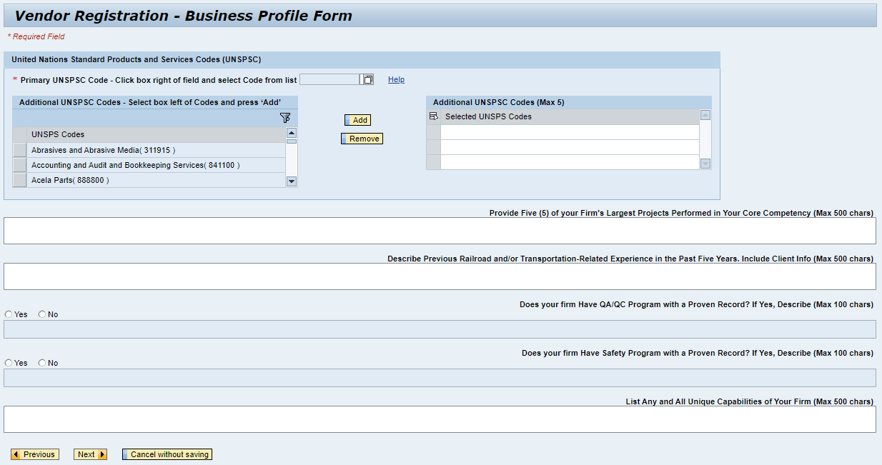

Page 5
