The purpose of this document is to provide assistance in downloading Amtrak’s current Diverse Vendor Directory. It is highly recommended at this time that, if you wish to analyze the current Diverse Vendor Directory, you export the directory to your local machine and view it using a spreadsheet program, such as Microsoft Excel. There, you can perform any searching and analyzing desired. The current view for the “In-Browser” directory can be cumbersome and difficult to navigate.

Contents
IMPORTANT NOTE REGARDING THIS DOCUMENT – PLEASE READ 2
HOW TO EXPORT THE DIVERSE VENDOR DIRECTORY 3
IF THE EXPORTED FILE HAS NO DEFAULT FILE TYPE 5

IMPORTANT NOTE REGARDING THIS DOCUMENT – PLEASE READ

What you see on your machine as you perform the steps detailed in this document may not be the same as the screenshots provided in this document. If you require any additional assistance regarding a non-Amtrak specific item not explained in this document, it is recommended that you perform a query using a common search engine (E.G. - www.google.com)
Examples of some additional assistance that may be required are; “How do I save a file to my computer?”, “How do I locate a file on my computer?”, “How do I rename a file on my computer?”, “Why can’t I change the extension of a file on my computer?”, or any other file/filename related issues that might be encountered.
The answers to these sorts of questions can vary greatly depending on various factors related to your local machine. The answers also may require a change to your browser settings and/or system settings and therefore, for any of these machine-specific questions, Amtrak will not be able to answer due to legal constraints. As such, Amtrak recommends that you perform your query on a common search engine as noted previously.
Two of these potential factors include, but are not limited to –
- The Operating System, Version, and various computer settings that are used on your machine (E.G. Windows 7, Windows 8, Windows 8.1, Mac OS X, Mac OS 10.0, Mac OS 10.1, etc.)
- The browser, browser version, and browser settings you are using to export the directory (E.G. Microsoft Internet Explorer (MSIE) 7, MSIE 8, Apple Safari 6.1, Apple Safari 7, Google Chrome 37, Google Chrome 38, etc.)

Amtrak appreciates your understanding and your willingness to work with us in this process. We are constantly taking aims to improve our user-experience in all aspects of the Procurement Portal. The current recommendation to export the Diverse Vendor Directory to your local machine so that it can be easily viewed and searched is not a permanent solution and we are currently researching ways to improve the in-browser view of this directory.

HOW TO EXPORT THE DIVERSE VENDOR DIRECTORY

Step 1: Click on the “Diverse Vendor Directory” link, next to “(From 07/23/2014)”
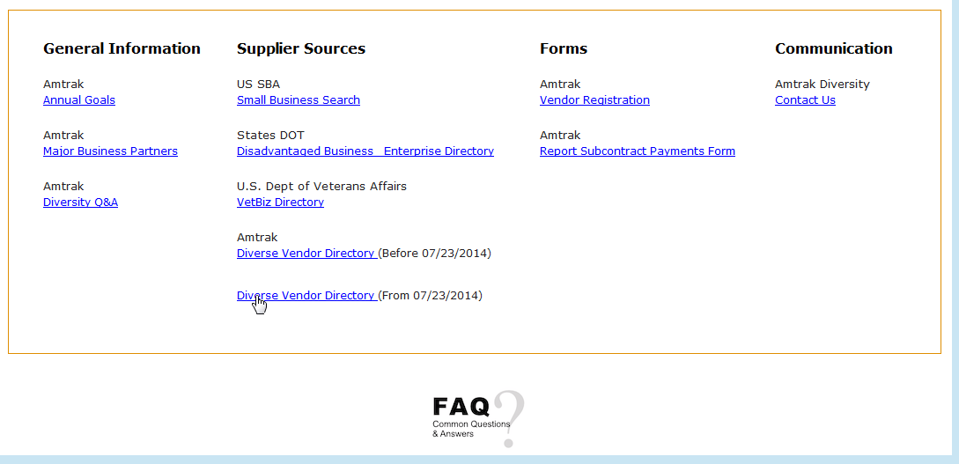

Step 2: Click on the “Export” button.
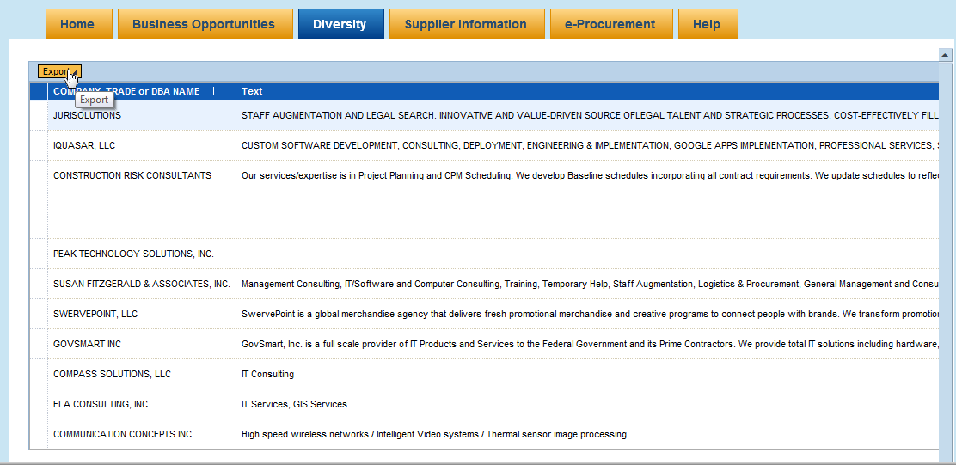

Step 3: Select the “Export to Microsoft Excel” option from the drop-down menu.
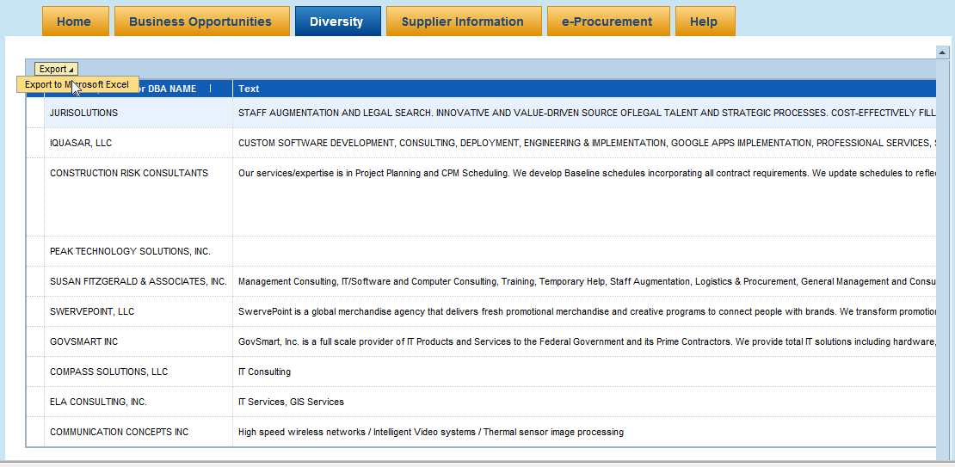

Step 4: You may see a notification like below based on various settings on your local machine. You can now save or open the file, as desired, as you normally would with any file. For Google Chrome users, your file may automatically be downloaded as “ZWA_PR_DIVERSE_VENDOR_REP” with no file association. If this occurs, please see the next section titled “If the Exported File has no Default File Type”.

IF THE EXPORTED FILE HAS NO DEFAULT FILE TYPE
(Filename is Missing the “.xls” at the End)

NOTE: This section is relevant for if your file is downloaded without a file type (There is no “.xls” at the end of the filename). If this happens, your computer does not have the required information to determine which program should be used to open the file.
If your file is downloaded without the file type after completing steps 1 through 4 of “How to Export the Diverse Vendor Directory”, you will need to rename the file by putting “.xls” at the end.

Step 1: You should see a similar screen as seen below, after having completed the “How to Export the Diverse Vendor Directory” section of this document.
As seen after accessing Amtrak’s current Diverse Vendor Report and clicking “Export to Microsoft Excel” using Google Chrome on a Windows 7 machine. The file is saved as “ZWA_PR_DIVERSE_VENDOR_REP”, seen at the bottom of the web browser in the screenshot below.
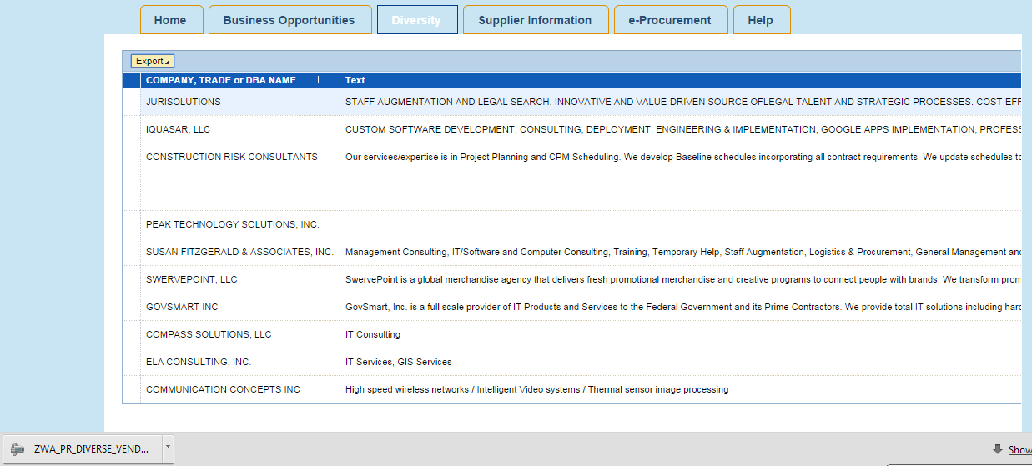

Step 2: Navigate to where on your machine the file was downloaded
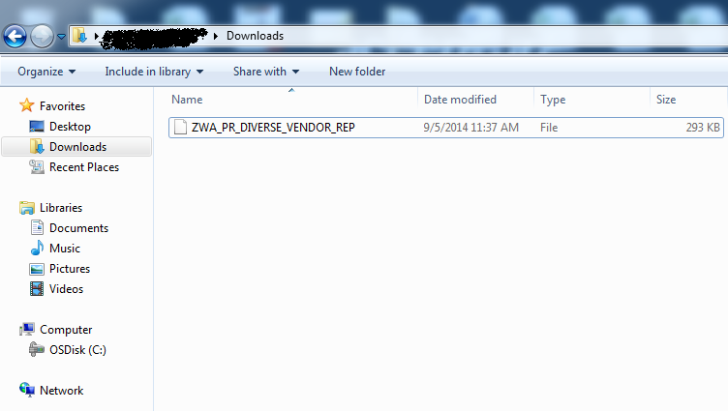

Step 3: After locating your file, change the filename so that “.xls” is at the end of the file. Doing this should associate this file to be opened with your machine’s default Spreadsheet Program.
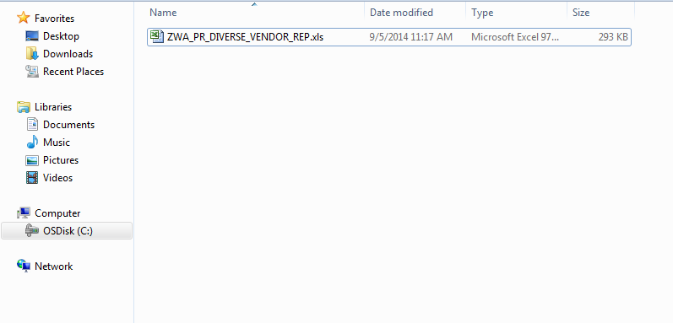
Step 4: Once your file is downloaded and the file is correctly associated, you should be able to properly open the file for any searching or analyzing, as desired.

